Order Of Service

Singing: Psalm 18—CW page 69

Reading: Psalm 105:12-22

Opening Hymn: TLH 26

Reading: Acts 22:1-5

Request Hymn: CW Supplement 729

Reading: Matthew 9:18-26

Sermon Hymn: TLH 135

Sermon Text: Mark 9:1-8

On A High Mountain

Prayer

The Apostles’ Creed, TLH page 12

Holy Communion

The Lord's Prayer

The Blessing

Closing Hymn: TLH 46

* * * * * * * * * * *

Bible Study: Lambs: Grizzly Bear
Sheep: Proverbs 19:21-25
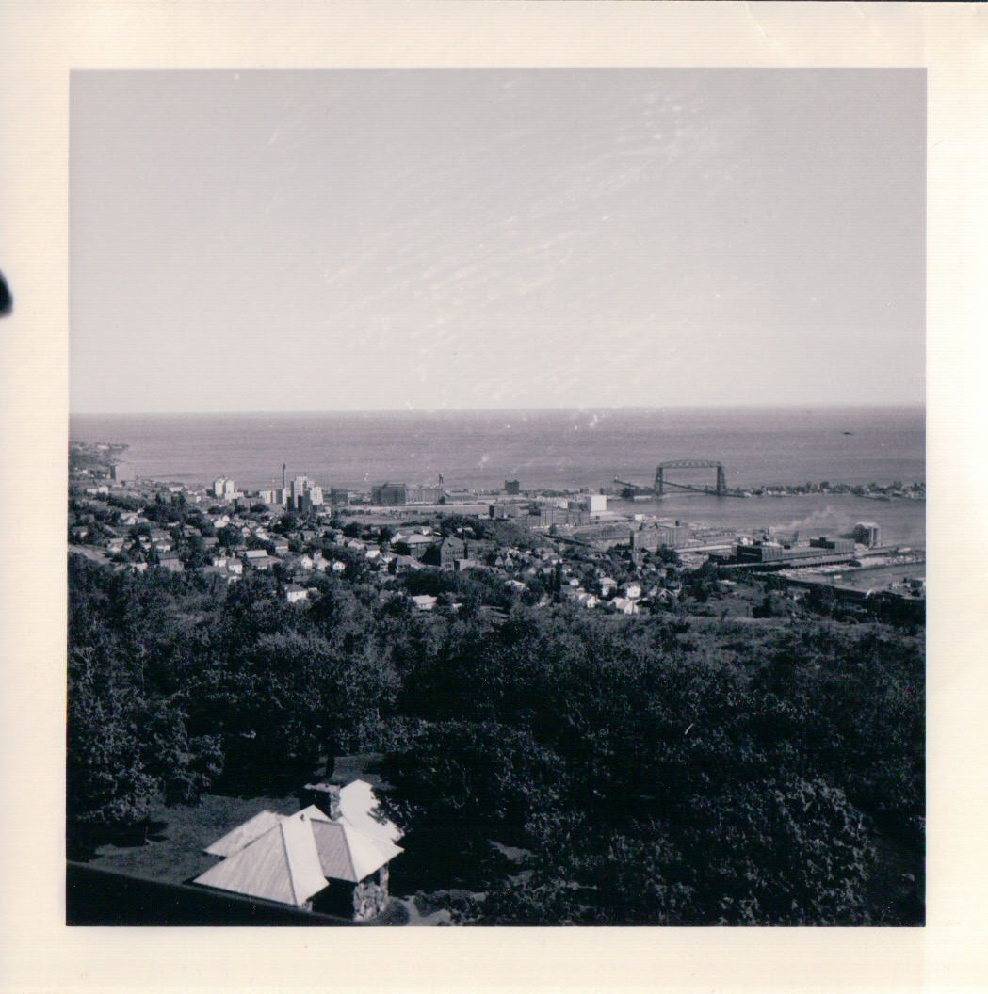

Sky Line Drive, Duluth, MN

Water
Of
Life
18 August 2019

W A T E R O F L I F E

Independent Christian Church—Conservative Lutheran Doctrine

Worship Service: 9:30 a.m. Bible Study: 10:45 a.m.

Larry Cooper, Pastor E-Mail address:
111 N. Ridge Road lcooper@wateroflife.cc
Coon Valley, WI 54623 Web Site:
www.wateroflife.cc

* * * * * * * * * * * * * * * * * * * * * * * * * * *

Sermon Text: Mark 9:1-8

On A High Mountain

* * * * * * * * * * * * * * * * * * * * * * * * * * *

Mark 9:1 And he said unto them, Verily I say unto you, That there be some of them that stand here, which shall not taste of death, till they have seen the kingdom of God come with power.
:2 And after six days Jesus taketh with him Peter, and James, and John, and leadeth them up into an high mountain apart by themselves: and he was transfigured before them.
:3 And his raiment became shining, exceeding white as snow; so as no fuller on earth can white them.
:4 And there appeared unto them Elias with Moses: and they were talking with Jesus.
:5 And Peter answered and said to Jesus, Master, it is good for us to be here: and let us make three tabernacles; one for thee, and one for Moses, and one for Elias.
:6 For he wist not what to say; for they were sore afraid.
:7 And there was a cloud that overshadowed them: and a voice came out of the cloud, saying, This is my beloved Son: hear him.
:8 And suddenly, when they had looked round about, they saw no man any more, save Jesus only with themselves.

